**Cahier des silhouettes**

**Images gratuites,**

**Libres de droits**

|  |  |  |  |  |  |  |  |  |  |  |  |  |  |  |  |  |  |  |  |  |  |  |  |  |  |  |  |  |  |  |
| --- | --- | --- | --- | --- | --- | --- | --- | --- | --- | --- | --- | --- | --- | --- | --- | --- | --- | --- | --- | --- | --- | --- | --- | --- | --- | --- | --- | --- | --- | --- |
| **NOM** | **1** | **2** | **3** | **4** | **5** | **6** | **7** | **8** | **9** | **10** | **11** | **12** | **13** | **14** | **15** | **16** | **17** | **18** | **19** | **20** | **21** | **22** | **23** | **24** | **25** | **26** | **27** | **28** | **29** | **30** |
|  |  |  |  |  |  |  |  |  |  |  |  |  |  |  |  |  |  |  |  |  |  |  |  |  |  |  |  |  |  |  |
|  |  |  |  |  |  |  |  |  |  |  |  |  |  |  |  |  |  |  |  |  |  |  |  |  |  |  |  |  |  |  |
|  |  |  |  |  |  |  |  |  |  |  |  |  |  |  |  |  |  |  |  |  |  |  |  |  |  |  |  |  |  |  |
|  |  |  |  |  |  |  |  |  |  |  |  |  |  |  |  |  |  |  |  |  |  |  |  |  |  |  |  |  |  |  |
|  |  |  |  |  |  |  |  |  |  |  |  |  |  |  |  |  |  |  |  |  |  |  |  |  |  |  |  |  |  |  |
|  |  |  |  |  |  |  |  |  |  |  |  |  |  |  |  |  |  |  |  |  |  |  |  |  |  |  |  |  |  |  |
|  |  |  |  |  |  |  |  |  |  |  |  |  |  |  |  |  |  |  |  |  |  |  |  |  |  |  |  |  |  |  |
|  |  |  |  |  |  |  |  |  |  |  |  |  |  |  |  |  |  |  |  |  |  |  |  |  |  |  |  |  |  |  |
|  |  |  |  |  |  |  |  |  |  |  |  |  |  |  |  |  |  |  |  |  |  |  |  |  |  |  |  |  |  |  |
|  |  |  |  |  |  |  |  |  |  |  |  |  |  |  |  |  |  |  |  |  |  |  |  |  |  |  |  |  |  |  |
|  |  |  |  |  |  |  |  |  |  |  |  |  |  |  |  |  |  |  |  |  |  |  |  |  |  |  |  |  |  |  |
|  |  |  |  |  |  |  |  |  |  |  |  |  |  |  |  |  |  |  |  |  |  |  |  |  |  |  |  |  |  |  |
|  |  |  |  |  |  |  |  |  |  |  |  |  |  |  |  |  |  |  |  |  |  |  |  |  |  |  |  |  |  |  |
|  |  |  |  |  |  |  |  |  |  |  |  |  |  |  |  |  |  |  |  |  |  |  |  |  |  |  |  |  |  |  |

**Tableau du choix des silhouettes**

|  |  |  |  |  |  |  |  |  |  |  |  |  |  |  |  |  |  |  |  |  |  |  |  |  |  |  |  |  |  |  |
| --- | --- | --- | --- | --- | --- | --- | --- | --- | --- | --- | --- | --- | --- | --- | --- | --- | --- | --- | --- | --- | --- | --- | --- | --- | --- | --- | --- | --- | --- | --- |
| **NOM** | **1** | **2** | **3** | **4** | **5** | **6** | **7** | **8** | **9** | **10** | **11** | **12** | **13** | **14** | **15** | **16** | **17** | **18** | **19** | **20** | **21** | **22** | **23** | **24** | **25** | **26** | **27** | **28** | **29** | **30** |
|  |  |  |  |  |  |  |  |  |  |  |  |  |  |  |  |  |  |  |  |  |  |  |  |  |  |  |  |  |  |  |
|  |  |  |  |  |  |  |  |  |  |  |  |  |  |  |  |  |  |  |  |  |  |  |  |  |  |  |  |  |  |  |
|  |  |  |  |  |  |  |  |  |  |  |  |  |  |  |  |  |  |  |  |  |  |  |  |  |  |  |  |  |  |  |
|  |  |  |  |  |  |  |  |  |  |  |  |  |  |  |  |  |  |  |  |  |  |  |  |  |  |  |  |  |  |  |
|  |  |  |  |  |  |  |  |  |  |  |  |  |  |  |  |  |  |  |  |  |  |  |  |  |  |  |  |  |  |  |
|  |  |  |  |  |  |  |  |  |  |  |  |  |  |  |  |  |  |  |  |  |  |  |  |  |  |  |  |  |  |  |
|  |  |  |  |  |  |  |  |  |  |  |  |  |  |  |  |  |  |  |  |  |  |  |  |  |  |  |  |  |  |  |
|  |  |  |  |  |  |  |  |  |  |  |  |  |  |  |  |  |  |  |  |  |  |  |  |  |  |  |  |  |  |  |
|  |  |  |  |  |  |  |  |  |  |  |  |  |  |  |  |  |  |  |  |  |  |  |  |  |  |  |  |  |  |  |
|  |  |  |  |  |  |  |  |  |  |  |  |  |  |  |  |  |  |  |  |  |  |  |  |  |  |  |  |  |  |  |
|  |  |  |  |  |  |  |  |  |  |  |  |  |  |  |  |  |  |  |  |  |  |  |  |  |  |  |  |  |  |  |
|  |  |  |  |  |  |  |  |  |  |  |  |  |  |  |  |  |  |  |  |  |  |  |  |  |  |  |  |  |  |  |
|  |  |  |  |  |  |  |  |  |  |  |  |  |  |  |  |  |  |  |  |  |  |  |  |  |  |  |  |  |  |  |
|  |  |  |  |  |  |  |  |  |  |  |  |  |  |  |  |  |  |  |  |  |  |  |  |  |  |  |  |  |  |  |

[](https://www.google.ca/url?sa=i&rct=j&q=&esrc=s&source=images&cd=&cad=rja&uact=8&ved=2ahUKEwjXzIP648jaAhWFdt8KHY5oBZMQjRx6BAgAEAQ&url=https://www.istockphoto.com/fr/photos/bonhomme-blanc&psig=AOvVaw33vRctQZtUNj-OAWhuPi3l&ust=1524310008122191)1

[](https://www.google.ca/url?sa=i&rct=j&q=&esrc=s&source=images&cd=&cad=rja&uact=8&ved=2ahUKEwj0l7-y5MjaAhUION8KHWekBqcQjRx6BAgAEAQ&url=https://pixabay.com/fr/thumbs-up-tube-digestif-pouce-haute-1026395/&psig=AOvVaw33vRctQZtUNj-OAWhuPi3l&ust=1524310008122191)2

[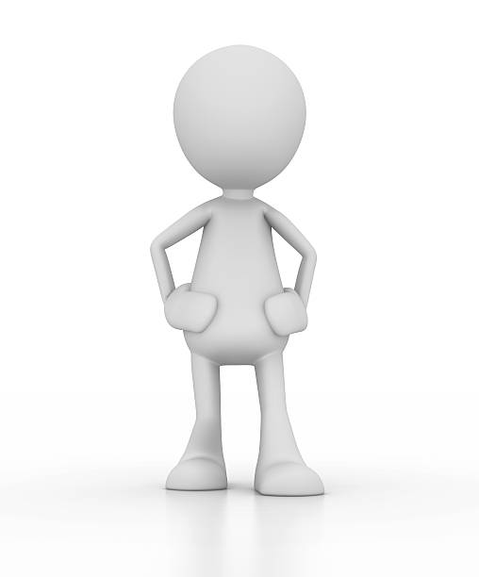](https://www.google.ca/url?sa=i&rct=j&q=&esrc=s&source=images&cd=&cad=rja&uact=8&ved=2ahUKEwjnk6XZ5MjaAhXvUd8KHVCdA9gQjRx6BAgAEAQ&url=https://www.istockphoto.com/fr/photos/bonhomme-blanc&psig=AOvVaw33vRctQZtUNj-OAWhuPi3l&ust=1524310008122191)3

[](https://www.google.ca/url?sa=i&rct=j&q=&esrc=s&source=images&cd=&cad=rja&uact=8&ved=2ahUKEwiL7Onx5MjaAhUDneAKHXtfA2wQjRx6BAgAEAQ&url=https://www.istockphoto.com/be/photos/bonhomme&psig=AOvVaw33vRctQZtUNj-OAWhuPi3l&ust=1524310008122191)4

5

[](https://www.google.ca/url?sa=i&rct=j&q=&esrc=s&source=images&cd=&cad=rja&uact=8&ved=2ahUKEwj2qumT5cjaAhVxn-AKHTGiApMQjRx6BAgAEAQ&url=https://pixabay.com/fr/la-musique-%C3%A9couter-danse-chansons-1013872/&psig=AOvVaw33vRctQZtUNj-OAWhuPi3l&ust=1524310008122191)

[](https://www.google.ca/imgres?imgurl=https://www.forzaconlepatate.it/wp-content/uploads/2017/11/utilizzatore.jpg&imgrefurl=https://www.forzaconlepatate.it/nuovi-posts/singolo-utilizzatore/utilizzatore/&docid=Q93OaHPAkWJuFM&tbnid=fiPuRxNTFxuVLM:&vet=1&w=383&h=405&bih=748&biw=1518&ved=2ahUKEwjPiba_5cjaAhWRUt8KHcVDCmIQxiAoBXoECAAQGQ&iact=c&ictx=1)6

[](https://www.google.ca/url?sa=i&rct=j&q=&esrc=s&source=images&cd=&cad=rja&uact=8&ved=2ahUKEwin2MP65cjaAhUSU98KHdZmAoUQjRx6BAgAEAQ&url=https://www.uecm.fr/alsace/index.php/le-saviez-vous&psig=AOvVaw33vRctQZtUNj-OAWhuPi3l&ust=1524310008122191)7

[](https://www.google.ca/url?sa=i&rct=j&q=&esrc=s&source=images&cd=&cad=rja&uact=8&ved=2ahUKEwjS5_Gp5sjaAhXIUt8KHVYNBd4QjRx6BAgAEAQ&url=https://www.istockphoto.com/fr/photos/bonhomme-blanc&psig=AOvVaw33vRctQZtUNj-OAWhuPi3l&ust=1524310008122191)8

[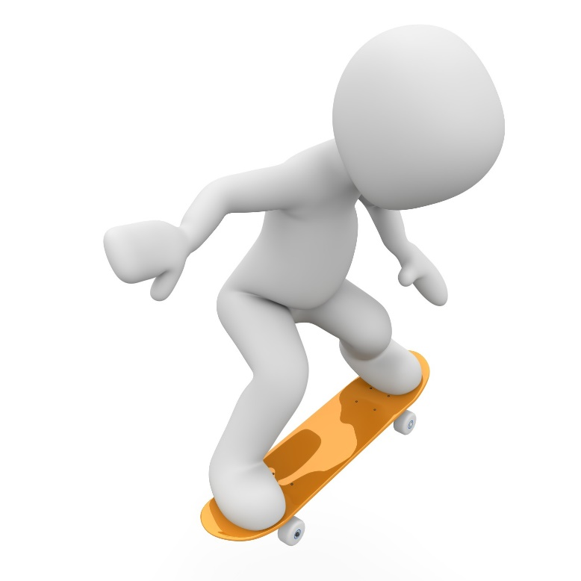](http://www.google.ca/url?sa=i&rct=j&q=&esrc=s&source=images&cd=&cad=rja&uact=8&ved=2ahUKEwizh6jh5sjaAhWvhOAKHXdJDDkQjRx6BAgAEAQ&url=http://fotomelia.com/?download%3Dbonhomme-blanc-3d-gratuit-libre-de-droit-31&psig=AOvVaw0fm9TUbNlr_MyMjvgRnlXP&ust=1524311966220159)9

[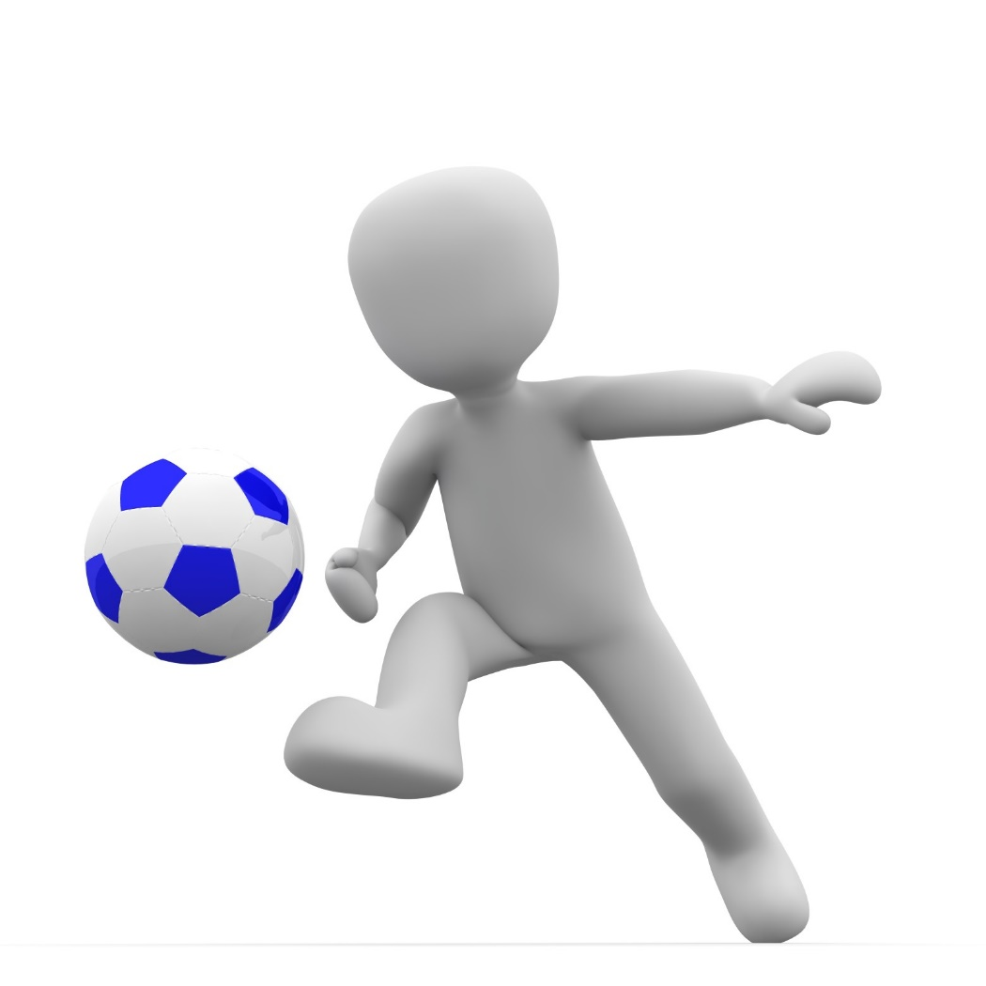](http://www.google.ca/url?sa=i&rct=j&q=&esrc=s&source=images&cd=&cad=rja&uact=8&ved=2ahUKEwizh6jh5sjaAhWvhOAKHXdJDDkQjRx6BAgAEAQ&url=http://fotomelia.com/?download%3Dhomme-footballeur-images-gratuites&psig=AOvVaw0fm9TUbNlr_MyMjvgRnlXP&ust=1524311966220159)10

[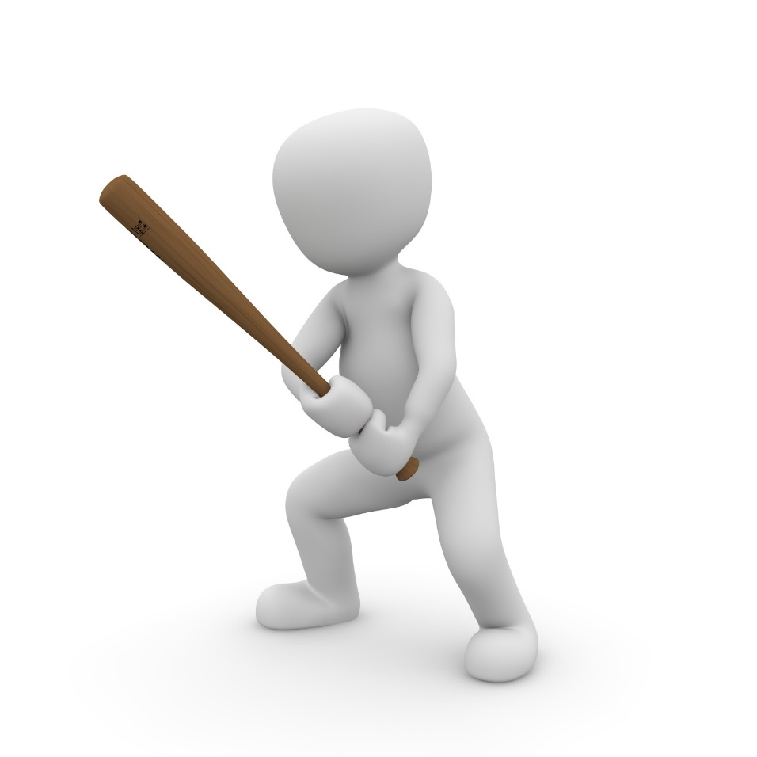](http://www.google.ca/url?sa=i&rct=j&q=&esrc=s&source=images&cd=&cad=rja&uact=8&ved=2ahUKEwizh6jh5sjaAhWvhOAKHXdJDDkQjRx6BAgAEAQ&url=http://fotomelia.com/?download%3Dbonhomme-blanc-3d-sport-images-gratuites-libres-de-droits-6&psig=AOvVaw0fm9TUbNlr_MyMjvgRnlXP&ust=1524311966220159)11

[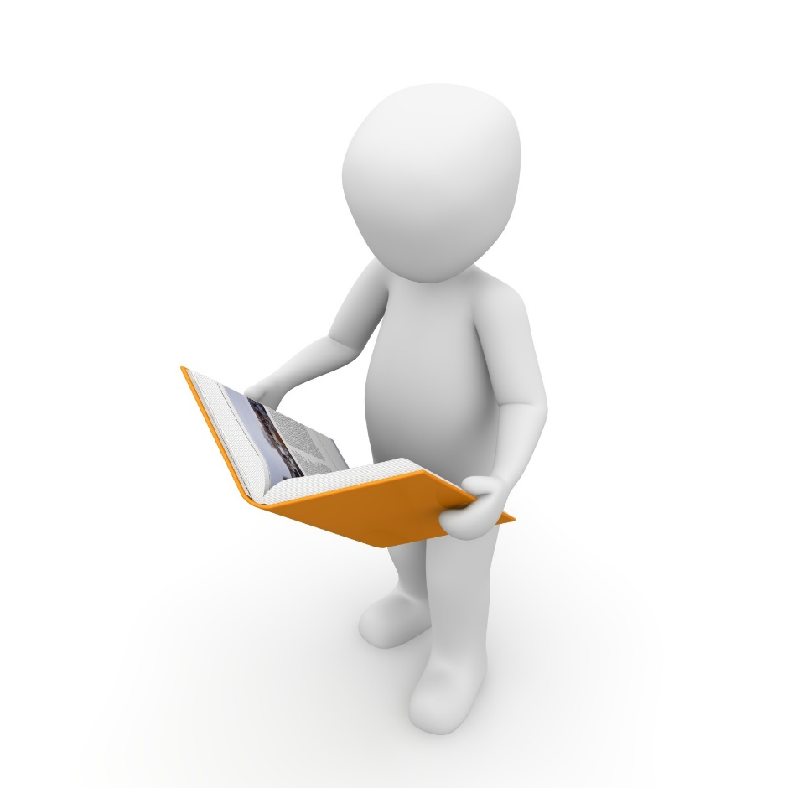](http://www.google.ca/url?sa=i&rct=j&q=&esrc=s&source=images&cd=&cad=rja&uact=8&ved=2ahUKEwjay8y058jaAhVOPN8KHbOFAOwQjRx6BAgAEAQ&url=http://fotomelia.com/?download%3Dbonhomme-blanc-3d-images-gratuites-creative-commons-2&psig=AOvVaw0fm9TUbNlr_MyMjvgRnlXP&ust=1524311966220159)12

[](http://www.google.ca/url?sa=i&rct=j&q=&esrc=s&source=images&cd=&cad=rja&uact=8&ved=2ahUKEwjay8y058jaAhVOPN8KHbOFAOwQjRx6BAgAEAQ&url=http://fotomelia.com/?download%3Dbonhomme-blanc-ordinateur-informatique-images-gratuites&psig=AOvVaw0fm9TUbNlr_MyMjvgRnlXP&ust=1524311966220159)13

[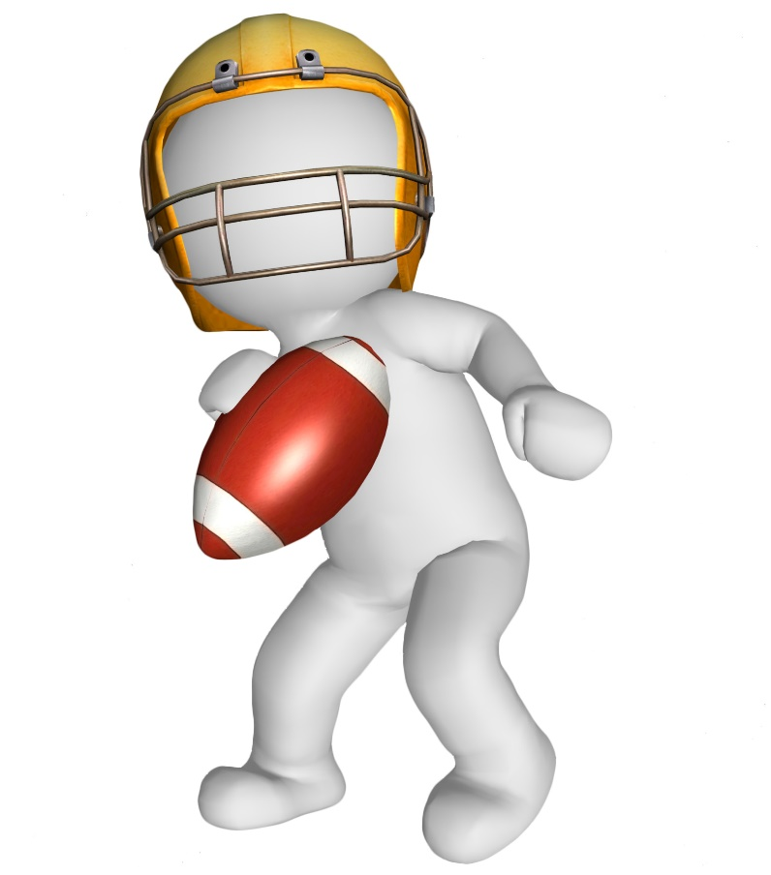](http://www.google.ca/url?sa=i&rct=j&q=&esrc=s&source=images&cd=&cad=rja&uact=8&ved=2ahUKEwi-z_KF6MjaAhXlTN8KHTvpCCIQjRx6BAgAEAQ&url=http://fotomelia.com/?download%3Dbonhomme-blanc-3d-images-gratuites-libres-de-droits-3&psig=AOvVaw0fm9TUbNlr_MyMjvgRnlXP&ust=1524311966220159)14

[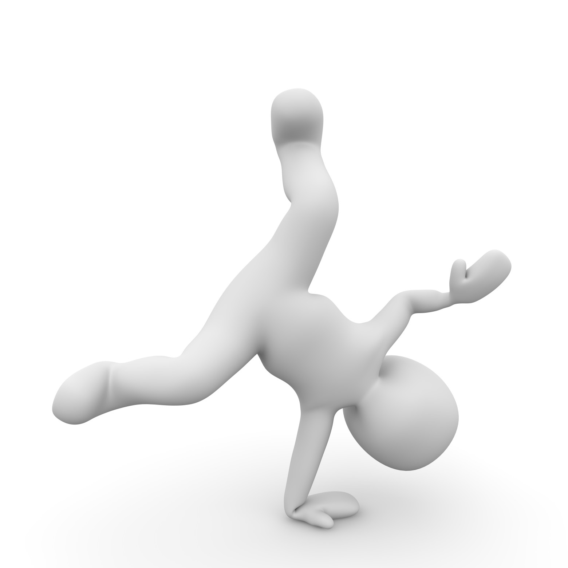](http://www.google.ca/url?sa=i&rct=j&q=&esrc=s&source=images&cd=&cad=rja&uact=8&ved=2ahUKEwiMn9u46MjaAhXpQd8KHbnTAcUQjRx6BAgAEAQ&url=http://fotomelia.com/?download%3Dbonhomme-blanc-3d-sport-images-gratuites-libres-de-droits-7&psig=AOvVaw3NiWX21CVZgnS1xEV280yO&ust=1524312421007280)15

[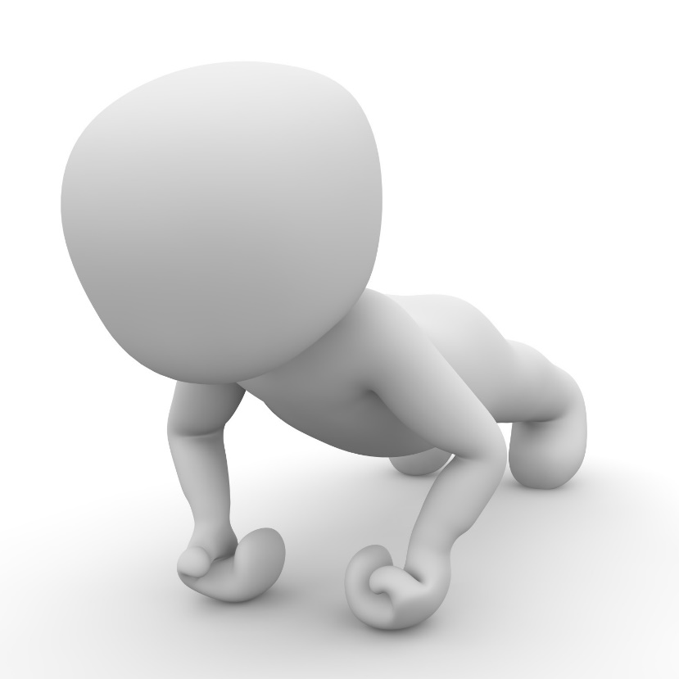](http://www.google.ca/url?sa=i&rct=j&q=&esrc=s&source=images&cd=&cad=rja&uact=8&ved=2ahUKEwiMn9u46MjaAhXpQd8KHbnTAcUQjRx6BAgAEAQ&url=http://fotomelia.com/?s%3Dbonhomme%2Bblanc%26post_type%3Ddownload%26paged%3D84&psig=AOvVaw3NiWX21CVZgnS1xEV280yO&ust=1524312421007280)16

[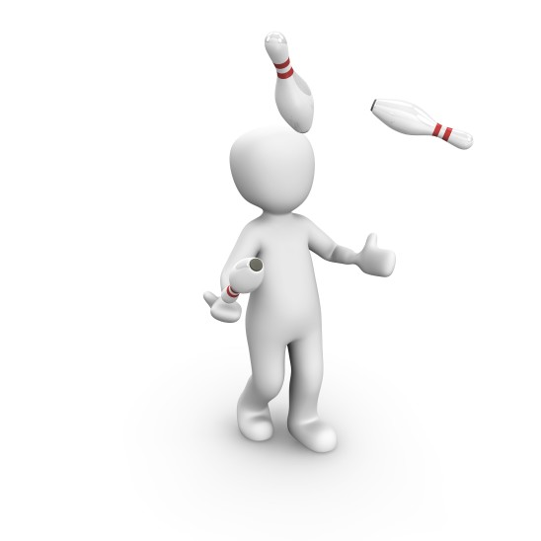](http://www.google.ca/url?sa=i&rct=j&q=&esrc=s&source=images&cd=&cad=rja&uact=8&ved=2ahUKEwjCysb26MjaAhXlmeAKHWHoB2UQjRx6BAgAEAQ&url=http://fotomelia.com/?s%3Dbonhomme%2Bblanc%26post_type%3Ddownload%26paged%3D57&psig=AOvVaw3JDtLkKzlj1sKRP6hwDQRW&ust=1524312546468237)17

[](http://www.google.ca/url?sa=i&rct=j&q=&esrc=s&source=images&cd=&cad=rja&uact=8&ved=2ahUKEwj6wK2d6cjaAhWPnOAKHc1DBR0QjRx6BAgAEAQ&url=http://isolda.co/Images-3d-Gratuites.html&psig=AOvVaw3JDtLkKzlj1sKRP6hwDQRW&ust=1524312546468237)18

[](https://www.google.ca/url?sa=i&rct=j&q=&esrc=s&source=images&cd=&ved=2ahUKEwiv7-ux6cjaAhUhVd8KHX7VDq0QjRx6BAgAEAQ&url=https://www.pinterest.fr/pin/503769908306120785/&psig=AOvVaw3JDtLkKzlj1sKRP6hwDQRW&ust=1524312546468237)19

[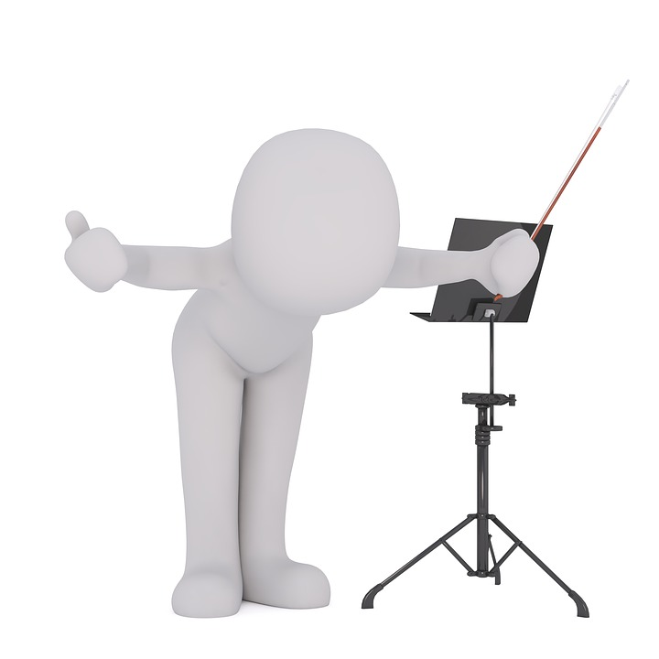](https://www.google.ca/url?sa=i&rct=j&q=&esrc=s&source=images&cd=&cad=rja&uact=8&ved=2ahUKEwiSot_e6sjaAhWDhOAKHaIRBmIQjRx6BAgAEAQ&url=https://pixabay.com/no/yrker-musikk-dirigent-gjennomf%C3%B8ring-2065278/&psig=AOvVaw3dmCWnv4faUXVtDr-MtyNL&ust=1524313012879512)20

[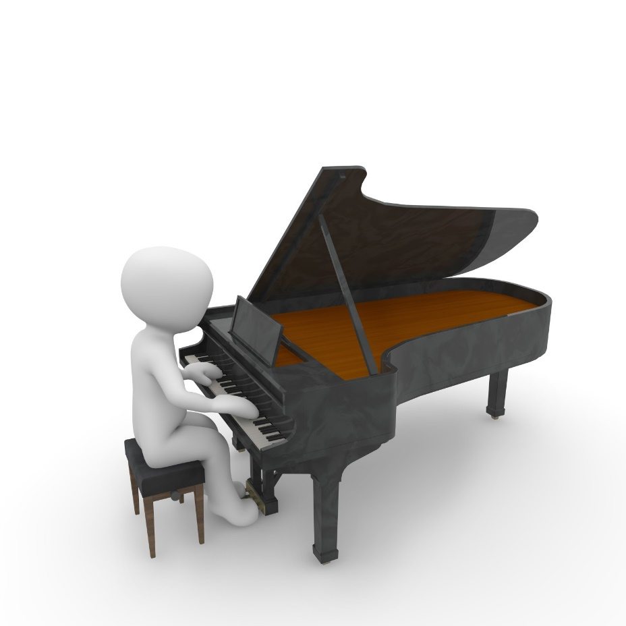](https://www.google.ca/url?sa=i&rct=j&q=&esrc=s&source=images&cd=&cad=rja&uact=8&ved=2ahUKEwie1vGb68jaAhWmmuAKHfVWBYYQjRx6BAgAEAQ&url=https://www.pinterest.fr/pin/358599189064134399/&psig=AOvVaw2FamUXpzmT3unHEozVvVWw&ust=1524313131317287)21

[](http://www.google.ca/url?sa=i&rct=j&q=&esrc=s&source=images&cd=&cad=rja&uact=8&ved=2ahUKEwi1g6nN7MjaAhUOPN8KHVUlDoEQjRx6BAgAEAQ&url=http://fotomelia.com/?s%3Dbonhomme%2Bblanc%2B3d,%2Bpersonnage%2B3d,%2Bfond%2Bblanc%26post_type%3Ddownload%26paged%3D42&psig=AOvVaw2_w85bSp0liLUXBxut-2Fu&ust=1524313524454458)22

[](http://www.google.ca/url?sa=i&rct=j&q=&esrc=s&source=images&cd=&cad=rja&uact=8&ved=2ahUKEwje_pD97MjaAhVDnuAKHStTAuEQjRx6BAgAEAQ&url=http://fotomelia.com/?download%3Dbonhomme-blanc-3d-gratuit-libre-de-droit-46&psig=AOvVaw1H0jue7Lgdpgqevl-ZLPRj&ust=1524313643010058)23

[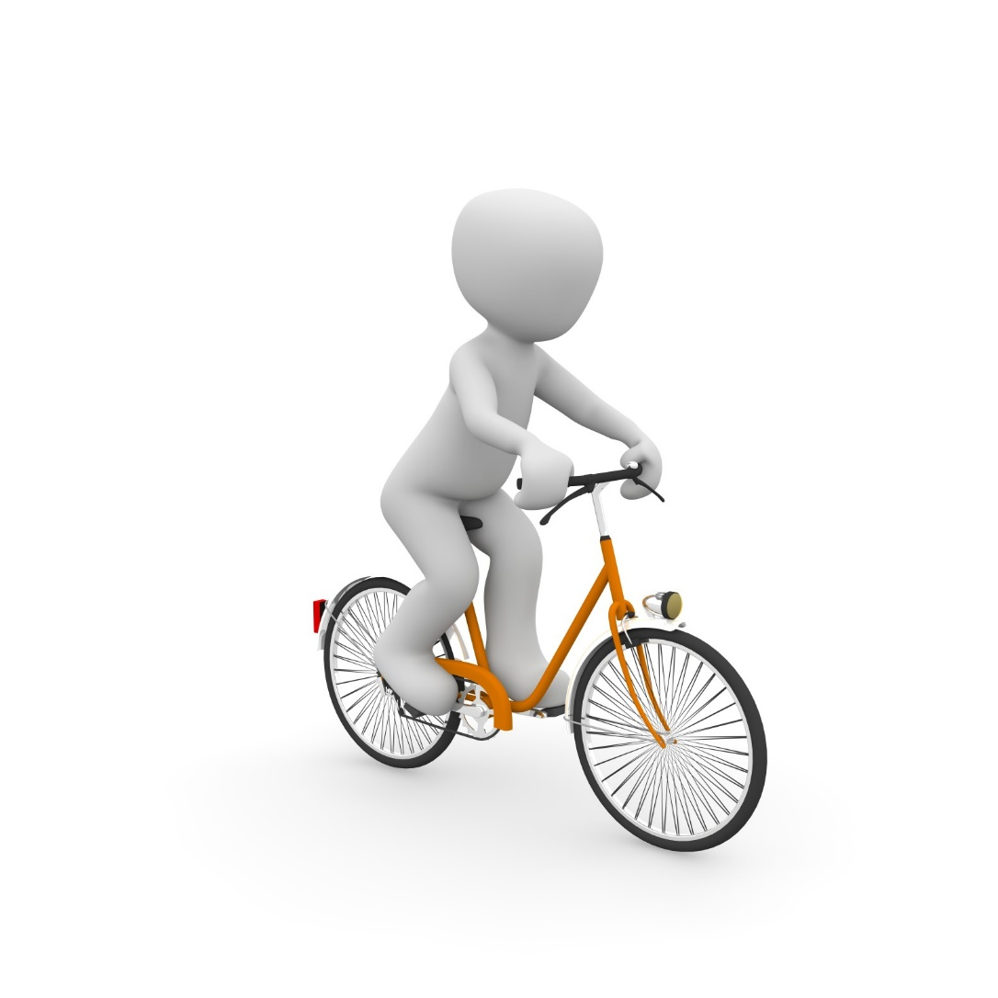](https://www.google.ca/url?sa=i&rct=j&q=&esrc=s&source=images&cd=&cad=rja&uact=8&ved=2ahUKEwi_1oaw7cjaAhUJPN8KHXKaAagQjRx6BAgAEAQ&url=https://www.pinterest.fr/pin/555842778993303118/&psig=AOvVaw2VY8zbTJzVT2bo536xzyGr&ust=1524313749741811)24

[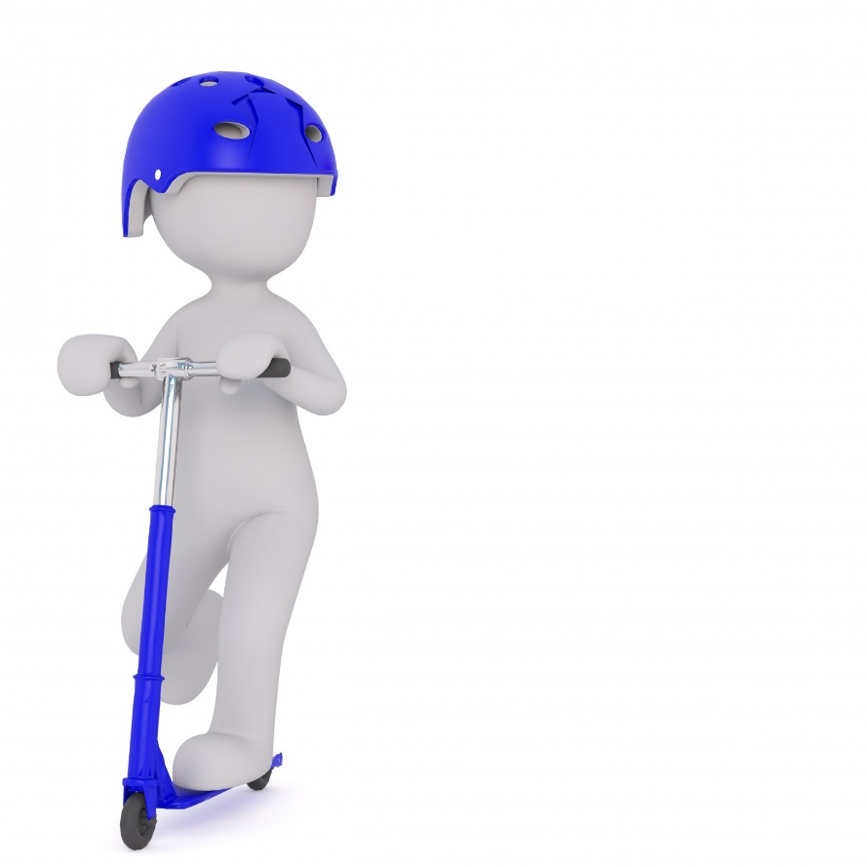](http://fotomelia.com/wp-content/uploads/2017/10/bonhomme-blanc-gratuit-sur-fotomelia-6-1560x1560.jpg)25

[](http://fotomelia.com/wp-content/uploads/2017/08/base-d-images-gratuites-13-1560x1560.jpg)26

[](http://fotomelia.com/wp-content/uploads/2017/08/banque-d-images-3d-gratuites-et-libres-de-droits-21-1560x1560.jpg)27

[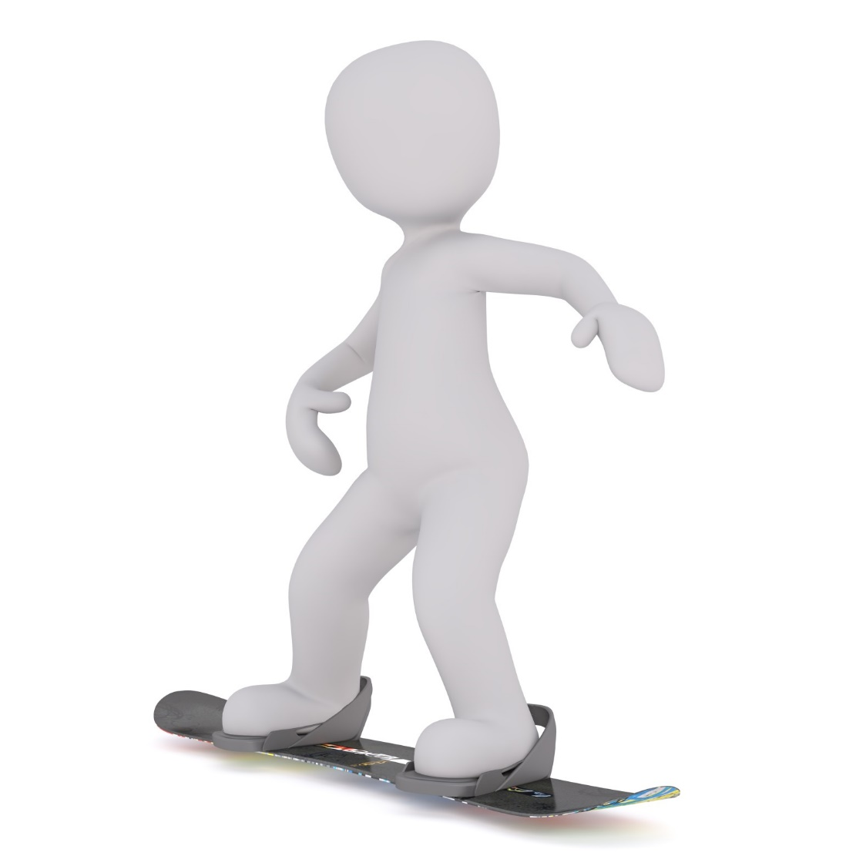](http://fotomelia.com/wp-content/uploads/2017/08/banque-d-images-3d-gratuites-et-libres-de-droits-20-1560x1560.jpg)28

29

[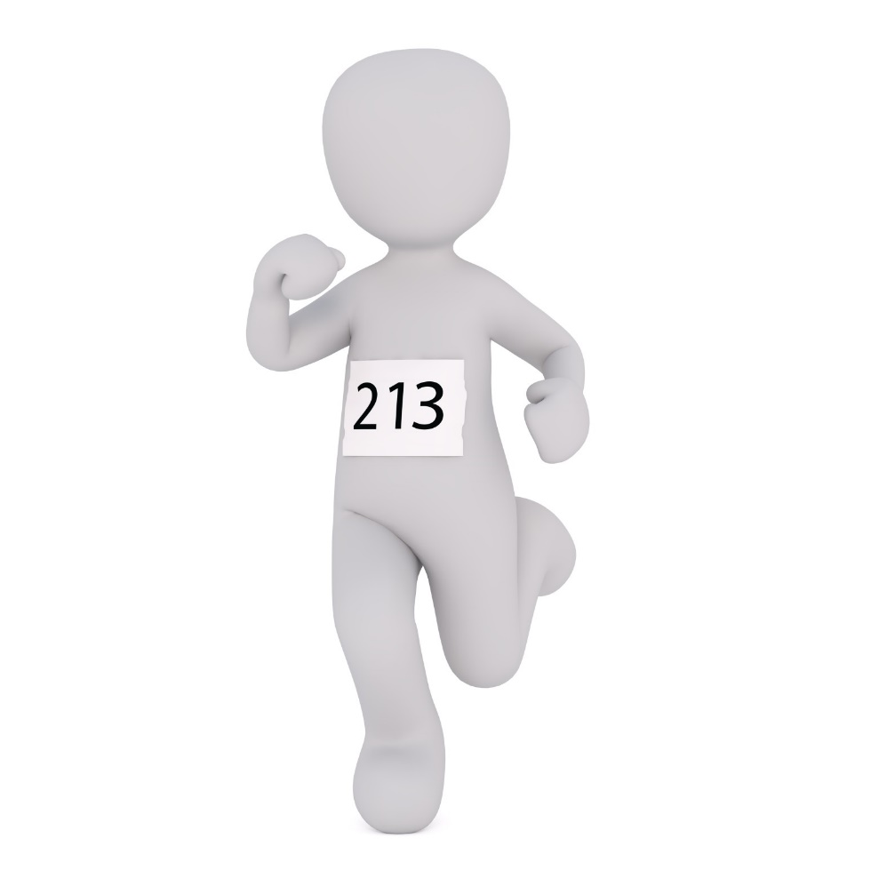](http://fotomelia.com/wp-content/uploads/2017/01/bonhomme-blanc-3d-images-gratuites-3-1560x1560.jpg)

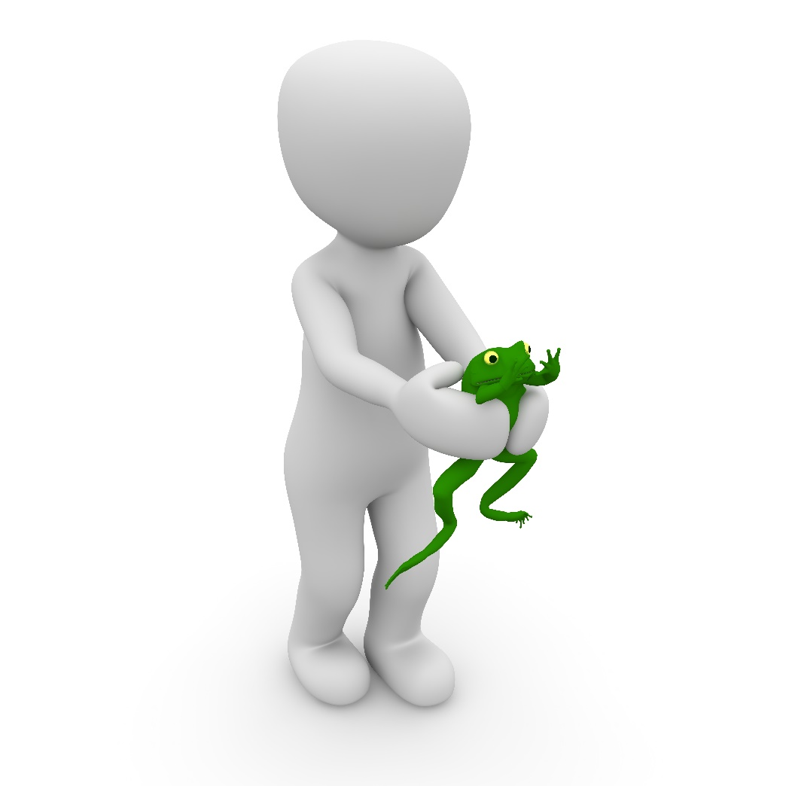30